Site Build Summary
Relien Property Maintenance, LLC
Quick rundown of what’s done, what to expect when leads start coming in, and what’s next.

The Site
Your new website is live now at a temporary address and will move to https://relienpm.com once the domain transfer finishes (about a week). It tells your story, shows what you do and who you serve, features your testimonials, includes an FAQ, and gives prospects a simple way to request a quote from any page. Customers can also attach photos of the work they need done, so you can size it up before driving out.

When a Lead Comes In
Every form submission lands directly in your inbox at info@relienpm.com. Each email includes:
- The customer’s name, contact info, and a clear description of what they need
- Any photos or PDFs they attached
- A clearly labeled “SMS Texting Consent: YES” or “NO” line. If they did not consent, the email is wrapped in a bright red “DO NOT TEXT” banner. This is legal protection for you under TCPA rules.
- When you hit Reply, your response goes straight to the customer’s email, not back to a system address
Note: Make a habit of checking your junk for the first month or two. Outlook may flag these as spam.

Security and Spam Protection
The form is built to keep junk, bots, and inappropriate content out of your inbox. Submissions are filtered through multiple layers before they reach you:
- Cloudflare Turnstile, an invisible bot-detection layer that blocks automated submissions before they ever hit the form
- Uploaded files are verified by their actual content, not just their filename. Only real photos and PDFs are allowed through.
- Spam patterns, suspicious links, all-caps messages, and submissions from unauthorized sources are rejected automatically
You should not see junk or inappropriate content arriving through the form.

Search Visibility
The site has a full set of search-engine foundations built into its code. Google and other engines will see Relien as a Birmingham-area Home and Construction business with named service areas across the metro. None of this is visible on the page itself, but it tells search engines exactly who you are, where you operate, and what you offer. Once the domain is fully live, I’ll register the site with Google Search Console to accelerate indexing.
Beyond Google, anyone sharing your site link through iMessage, Facebook, LinkedIn, or email will see a clean, branded preview card with the Relien logo and slogan instead of a plain URL.

What This Costs You
The only recurring expense is the annual domain renewal at Namecheap (about $10 per year). Everything else, including hosting, the form backend, email delivery, bot protection, and SEO, runs on free service tiers.

Time Investment
I have spent approximately 13 hours on this so far, covering design, content, the domain transfer, the contact and quote system, the security layer, and the SEO foundation. A couple more hours of work will follow over the coming days to finalize the domain switchover and submit the sitemap to Google Search Console.

What’s Next
When the domain transfer completes (roughly a week from initiation), the new site at https://relienpm.com goes live. Your existing Wix site will stop serving at that moment, and the new site takes its place. Your email at info@relienpm.com continues to work without interruption throughout the transition.
If anything ever needs updating, whether it’s text changes, new testimonials, new services, or new social links, just let me know and I’ll handle it.

Accounts:
You own all of the following accounts. All but the domain is “set it and forget it”
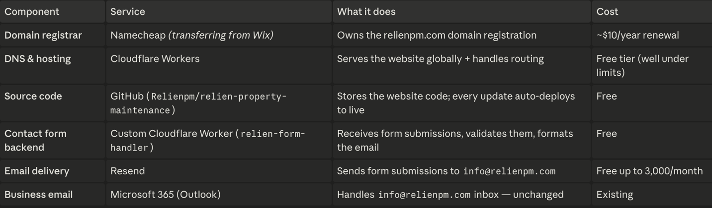
ACCOUNT ACCSESS FOR ALL ABOVE:
USERNAME: info@relienpm.com
Password: Reapair26!
The password for “RESEND”: Repair2026!

